Communication 101

**Fundamentals of Communication**

**Department of Communication, College of Social Sciences & Public Affairs**

# Fall 2014: Tu/Th, Section 22 1:30-2:45 p.m. (C226)

# Tu/Th, Section 23 3:00-4:15 p.m. (C226)

__________________________________________________________________________________

**Instructor:** Tabitha Simenc

**TabithaSimenc@boisestate.edu** (e-mails checked daily M-F during business hours)

*Tabitha Simenc is an instructor in the Communication Department at Boise State University. Originally from Oxford, England, she received her master’s degree in Communication and undergraduate degree in Mass Communication and Journalism from Boise State, graduating with highest honors. Between degrees she worked as a successful news reporter at The Idaho Press-Tribune, a local newspaper. With a focus on education and business reporting, Tabitha covered a variety of topics important to the local community and received an Idaho Press-Club Award for agricultural reporting in 2011. Tabitha has a passion for community awareness, equality, media and government; she combines these interests with communication in her research.*

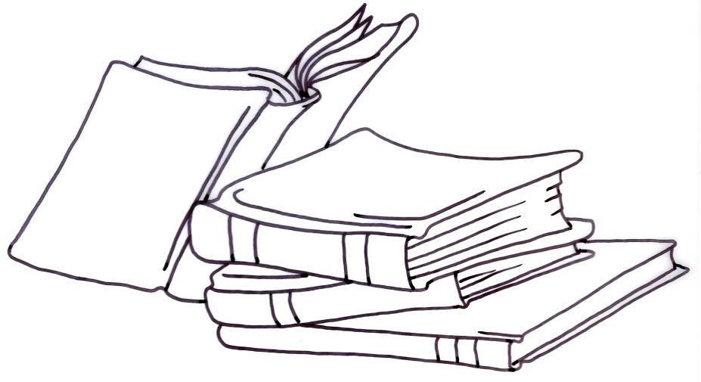**Office/Hours:**  Office C217 (upstairs in the Communication building.)

Office hours: Tu/Th before and after class and by appointment.

**Text:** Worley, D. W., Worley, D. A., and Soldner, L. *Communication counts in college, career, and life: A custom edition for Boise State University.* ISBN #s: 978-1-269-43508-6 and 1-269-43508-6

**Course Description (from the Boise State University 2014-2015 Undergraduate Catalog):**

“Fundamental principles of verbal, nonverbal, written, and visual communication

with an introduction to relational and organizational communication, public communication, and media studies” (p. 96).

**The class will prepare students to enhance their communication skills and knowledge in ways they can apply to their daily lives, work and education.**

**Course Overview:** COMM 101 is a Boise State Foundational Studies Program course (Disciplinary

Lens Social Science, or DLS). According to the **Boise State University 2014-2015 Undergraduate Catalog**, courses within the Foundational Studies Program “. . . focus on the kinds of inquiry central to a university education, creating opportunities to explore important subjects, ask questions, debate ideas, increase understandings, research, innovate, and solve problems” (p. 49). The University Learning Outcome (ULO) for COMM 101 is #11— “Apply knowledge and the methods of inquiry characteristic of the social sciences to explain and evaluate human behaviors and institutions” (p. 49).

**Communication:**Facilitate your learning experiences by utilizing appointment times outside of class to ask questions, discuss goals, or seek help in improving your academic performance.

**Student testimonials:**

*****“This class taught me many life skills that I know I will use far into the future. Communication is an aspect of our lives that many people take for granted. I did not realize the importance of communication until taking this course.” – Freshman, engineering major.*

*“I’m definitely not as nervous when speaking in front of a group anymore. I actually would have liked to give more speeches” – Freshman, business major.*

*“I really enjoyed learning about non-verbal communication and how people communicate without speaking” – Freshman, Kinesiology major.*

*“I feel like this class helped me in my relationships greatly. I know how to communicate more effectively and this helps strengthen and maintain relationships” – Sophomore, English major.*



**Grading:** Participation *(10 points per class)* 300

“Communication Activity” reports 30

Exercises 80

Additional activities/quizzes 70

Midterm exam 100

Impromptu activities 20

Informative speech 100

Persuasive group project 100

Final exam 200

1,000

|  |  |  |  |
| --- | --- | --- | --- |
| **Letter Grade** | Meaning | **Points attained in class** | **Quality Points** |
| A+ | Distinguished work | 970 – 1000 pts. | 4.0 |
| A | Distinguished work | 930 – 969 pts. | 4.0 |
| A- | Distinguished work | 900 – 929 pts. | 3.7 |
| B+ | Superior work | 870 – 899 pts. | 3.3 |
| B | Superior work | 830 – 869 pts. | 3.0 |
| B- | Superior work | 800 – 829 pts. | 2.7 |
| C+ | Average work | 770 – 799 pts. | 2.3 |
| C | Average work | 730 – 769 pts. | 2.0 |
| C- | Average work | 700 – 729 pts. | 1.7 |
| D+ | Below-average work | 670 – 699 pts. | 1.3 |
| D | Below-average work | 630 – 669 pts. | 1.0 |
| D- | Below-average work | 600 – 629 pts. | .7 |
| F | Failure | below 600 pts. | 0 |

**Participation:** In-class participation counts for 30 percent of your grade. How do you get points?

* Show up to class on time. Remain until dismissed.

(Late arrival or early departure drops your points by half.)

* Pay attention, minimize distractions, and be engaged and mindful.
* Participate verbally and nonverbally in a civil, polite manner.
* Eliminate “side conversations” and computer use that disrupts the learning process for others or interferes with the primary classroom activity.
* Keep cell phones on silent and stowed in your backpack.

**“Communication Activity” Reports, Exercises, Additional Activities/Quizzes, and Speeches:**

Written explanations of “Communication Activity” Reports, Exercises, Additional Activities/Quizzes and Speeches will be provided to you in class.

**Exams:** The Midterm and the Final exams will be short answer/essay, multiple choice, and true/false. Each exam will integrate material from class activities, exercises, lectures, additional readings, and the textbook. Exam review sheets will be provided to you in class.

**Record Keeping:** Keep copies of all assignments, exercises, answer sheets, etc. for future reference.

**Requirements:** Work must be turned in during class—**assignments will not be accepted via email**.

Unless specified, **all assignments must be typed and stapled**.

Please proof read and spell check your work.

**ALL exams, the informative speech, and the persuasive group project must be**

**completed for a grade to be given in the class.**

**Late work:** With the exception of extenuating circumstances, if you miss any activity listed

in the Class Schedule or any graded activity added to the syllabus as the semester proceeds, your score on that activity **drops in half.** Some activities, such as in-class exercises, **cannot be made up.** Late work will NOT be accepted via e-mail. Late assignments must be submitted by the next class date.

**Conduct:** According to the **Boise State University Student Code of Conduct**, “The classroom is not an unstructured political forum; it is the center for study and understanding of subject matter for which the faculty member has professional responsibility and institutional accountability” (p. 2).

From the *Statement of Shared Values* from the **Office of Student Rights and Responsibilities**, “Membership in the campus community is a privilege and requires its members to conduct themselves ethically with integrity and civility” (p. 1).

From the **Boise State University 2014-2015 Undergraduate Catalog**, “Boise State University challenges its students to reach their highest levels of performance . . . (and) conduct themselves in a manner compatible with the university’s function as an institution of higher learning” (p. 21).

And finally, as stated in the **Student Code of Conduct**, an important component of Boise State University “. . . is to create an environment where civil discourse may occur free from discrimination, harassment, threats, or intimidation” (p. 1).

In alignment with these premises, the Department of Communication anticipates that COMM students will conduct themselves in a manner befitting all academic and personal responsibilities as set forth by Boise State University.

Accommodations: Whenever available, videos chosen for use in the course will be those that have

been close-captioned by the content producer to provide access to students with hearing impairment. PowerPoint presentations used in class lectures, insofar as they contain graphs or other visual representations of content, will be verbally described to students on an as-needed basis. Extra time on tests, oral examinations, or other accommodations will be provided to students as needed per the policies of the Disability Resource Center. Images used in Blackboard sites will have appropriate textual descriptions that can be read by screen reader software. In all sections, students will be able to submit assignments in a variety of formats, including written papers, uploading to Blackboard, or e-mail. The Department will work with Academic Technologies for help on electronic documents to ensure accessibility.

**Academic Integrity:** According to the **Boise State University 2014-2015 Undergraduate Catalog**, “The university’s goal is to foster an intellectual atmosphere that produces educated, literate people. Because cheating and plagiarism are at odds with that goal, those actions shall not be tolerated in any form . . . . (A)ll work submitted by a student must represent that student’s own ideas and effort; when the work does not, the student has engaged in academic dishonesty.

“ . . . (A)cademic dishonesty occurs whenever a student:

* buys a paper or other project, then seeks to receive credit for the paper or project
* copies from another student’s exam, either before, during, or after the exam
* uses “crib notes” while taking an exam or uses information stored in a computer or calculator (if prohibited from doing so)
* allows another person to take an exam in his or her place or takes an exam for another person
* collaborates on take-home exams when such collaboration is forbidden
* copies the work of another person and attempts to receive credit for that work
* fails to properly document source material in a paper or project
* receives editorial assistance that falls outside the scope of acceptable assistance

“**NOTE:** The list above is intended only to provide general guidelines for

recognizing and avoiding common types of academic dishonesty. It is in no way an exhaustive or comprehensive list of all the types of academic dishonesty” (p. 22).

“If a student is responsible of academic dishonesty, the student may be

dismissed from the class and may receive a failing grade. Other penalties may include suspension or expulsion from school” (p. 22).

To be safe in your classes, assume that you are to:

* complete every project independently
* properly cite sources
* present “original work”
* ask instructors for clarification

**Attendance:** Attendance is taken seriously. Missing a class means missing content. According to the **Boise State University 2014-2015 Undergraduate Catalog**, “You are responsible for attending courses for which you are enrolled. You are also responsible for making up any work you may have missed by failing to attend class, even if the absence was approved by the university, necessitated by illness, or necessitated by a personal emergency. In this sense, then, there are no ‘excused’ absences” (p. 32).

In emergency situations, please email tabithasimenc@boisestate.edu and provide a number where you can be reached.

Provide written documentation in advance if you know you will be missing a class. Include the day/date of the absence and the activities/assignments listed on the Class Schedule. We will set an appointment to discuss possible accommodations.

Official BSU Activity Absences (Policy 4240-D) need proper written documentation prior to the absence so that appropriate arrangements can be made.

**Based on Department of Communication policy for COMM 101, if you miss more than three classes in a TuTh class, a grade of “F” may be assigned.**

Accommodations: Whenever available, videos chosen for use in the course will be those that have

been close-captioned by the content producer to provide access to students with hearing impairment. PowerPoint presentations used in class lectures, insofar as they contain graphs or other visual representations of content, will be verbally described to students on an as-needed basis. Extra time on tests, oral examinations, or other accommodations will be provided to students as needed per the policies of the Disability Resource Center. Images used in Blackboard sites will have appropriate textual descriptions that can be read by screen reader software. In all sections, students will be able to submit assignments in a variety of formats, including written papers, uploading to Blackboard, or e-mail. The Department will work with Academic Technologies for help on electronic documents to ensure accessibility.

Course Concerns? Email COMM 101 Director Rebecca Robideaux Tiedge at rebeccarobideaux@

boisestate.edu to schedule an appointment to discuss your concerns.